**Hands on 1**

**Spring Data JPA - Quick Example**

* **Create a Eclipse Project using Spring Initializr.**

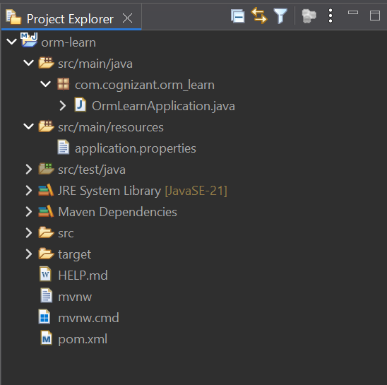

* **Application.properties:**

spring.application.name=orm-learn

# Spring Framework and application log

logging.level.org.springframework=info

logging.level.com.cognizant=debug

# Hibernate logs for displaying executed SQL, input and output

logging.level.org.hibernate.SQL=trace

logging.level.org.hibernate.type.descriptor.sql=trace

# Log pattern

logging.pattern.console=%d{dd-MM-yy} %d{HH:mm:ss.SSS} %-20.20thread %5p %-25.25logger**{25}** %25M %4L %m%n

# Database configuration

spring.datasource.driver-class-name=com.mysql.cj.jdbc.Driver

spring.datasource.url=jdbc:mysql://localhost:3306/ormlearn

spring.datasource.username=root

spring.datasource.password=1234

# Hibernate configuration

spring.jpa.hibernate.ddl-auto=validate

spring.jpa.properties.hibernate.dialect=org.hibernate.dialect.MySQLDialect

* **Include logs for verifying if main() method is called.**

CODE:

import org.slf4j.Logger;

import org.slf4j.LoggerFactory;

private static final Logger LOGGER = LoggerFactory.getLogger(OrmLearnApplication.class);

public static void main(String[] args) {

SpringApplication.run(OrmLearnApplication.class, args);

  LOGGER.info("Inside main");

}

After running the main() method,

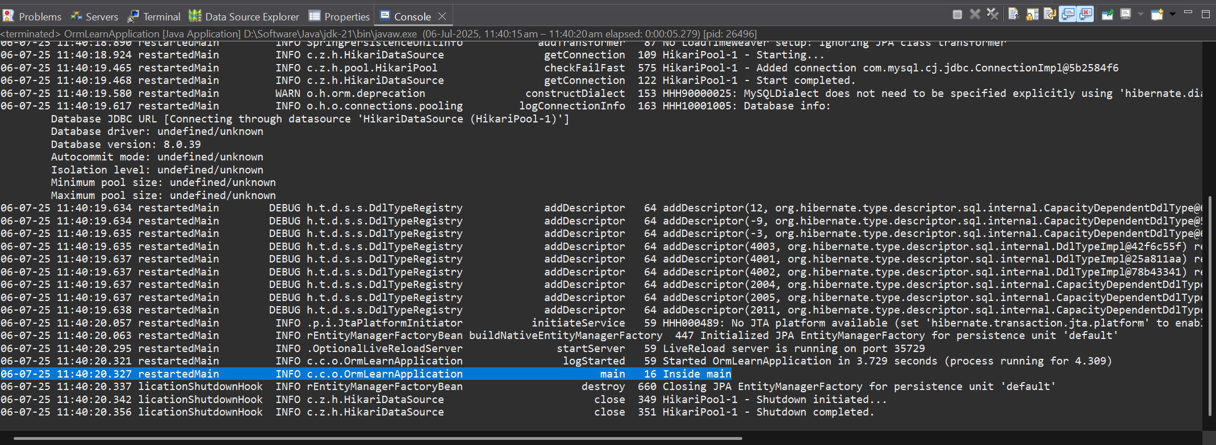

* **Country class: (Model)**

package com.cognizant.orm_learn.model;

import jakarta.persistence.Column;

import jakarta.persistence.Entity;

import jakarta.persistence.Id;

*@Entity*

public class Country {

*@Id*

*@Column*(name="co_code")

private String code;

*@Column*(name="co_name")

private String name;

public String getCode() {

return code;

}

public void setCode(String code) {

this.code = code;

}

public String getName() {

return name;

}

public void setName(String name) {

this.name = name;

}

*@Override*

public String toString() {

return "Country [code=" + code + ", name=" + name + "]";

}

}

* **CountryRepository class: (Repository)**

package com.cognizant.orm_learn.repository;

import org.springframework.data.jpa.repository.JpaRepository;

import com.cognizant.orm_learn.model.Country;

public interface CountryRepository extends JpaRepository<Country, String> {

}

* **CountryService class: (Service)**

package com.cognizant.orm_learn.service;

import java.util.List;

import org.springframework.beans.factory.annotation.Autowired;

import org.springframework.stereotype.Service;

import com.cognizant.orm_learn.model.Country;

import com.cognizant.orm_learn.repository.CountryRepository;

import jakarta.transaction.Transactional;

*@Service*

public class CountryService {

*@Autowired*

private CountryRepository repo;

public void setRepo(CountryRepository repo) {

this.repo = repo;

}

*@Transactional*

public List<Country> getAllCountries(){

return repo.findAll();

}

}

* **OrmLearnApplication class: (MAIN)**

package com.cognizant.orm_learn;

import org.springframework.boot.SpringApplication;

import org.springframework.boot.autoconfigure.SpringBootApplication;

import org.springframework.context.ApplicationContext;

import com.cognizant.orm_learn.model.Country;

import com.cognizant.orm_learn.service.CountryService;

import java.util.List;

import org.slf4j.Logger;

import org.slf4j.LoggerFactory;

*@SpringBootApplication*

public class OrmLearnApplication {

private static final Logger ***LOGGER*** = LoggerFactory.*getLogger*(OrmLearnApplication.class);

private static CountryService *countryService*;

private static void testGetAllCountries() {

***LOGGER***.info("Start");

List<Country> countries = *countryService*.getAllCountries();

***LOGGER***.debug("countries={}", countries);

***LOGGER***.info("End");

}

public static void main(String[] args) {

ApplicationContext context = SpringApplication.*run*(OrmLearnApplication.class, args);

*countryService* = context.getBean(CountryService.class);

*testGetAllCountries*();

}

}

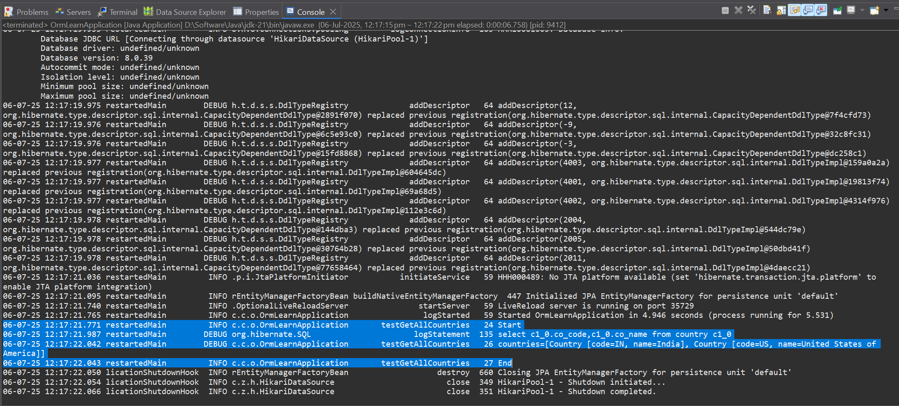**OUTPUT:**

**Hands on 4**

**Difference between JPA, Hibernate and Spring Data JPA**

**JPA**

* JPA is a specification that defines how ORM tools should function.

**HIBERNATE**

* Hibernate is an actual implementation of JPA that provides ORM capabilities.

**SPRING DATA JPA**

* Does not have JPA implementation, but reduces boiler plate code
* This is another level of abstraction over JPA implementation provider like Hibernate
* Manages transactions